  Photo by Matheus Henrin: https://www.pexels.com/ photo/woman-sitting-on-beige-floor-tile-2121323/ | The Smarter Bet:  Latin America's Retail Future Depends on AI in Procurement, Not Just Marketing  Peter Benda & ChatGPT  June 26, 2025

The Bottom Line

For Spanish-speaking Latin America, the smartest AI investment today isn’t another chatbot or e-commerce recommender engine. It’s AI in procurement and supply chain management. While customer-facing AI promises top-line gains, procurement-focused AI delivers faster, higher ROI through cost reduction, resilience, and operational efficiency. In a region grappling with volatility, underdeveloped infrastructure, and fragmented data systems, AI-enabled procurement is the key to sustainable EBITDA growth.

The Supply Chain Reality for Latin American Retailers

Retailers in Latin America are navigating a minefield of logistical and operational challenges. Fragmented infrastructure across borders, regulatory inconsistencies, frequent port delays, and global supply chain disruptions have exposed the vulnerabilities of legacy systems. Add to this a lack of last-mile logistics in rural areas and chronic inaccuracies in demand forecasting, and the result is a costly, rigid supply network.

Manual data entry and Excel-based workflows still dominate in many mid-sized operations. According to recent regional studies, only 12% of companies report using predictive analytics effectively, and more than 60% say their systems are not properly integrated. The outcome? Frequent stockouts, excess inventory, missed contract opportunities, and wasted spend.

AI in Retail: Not All ROI Is Created Equal

While AI adoption is increasing in Latin America, most initiatives remain customer-facing: dynamic pricing tools, personalization engines, or digital chat assistants. These technologies can help grow gross merchandise value (GMV) and customer retention, but they often require heavy capital investment and yield marginal EBITDA impact.
On the other hand, AI in procurement and supply chain optimization can yield measurable and immediate benefits. Global benchmarks show that AI-enabled sourcing, supplier scoring, forecasting, and logistics planning can deliver 5–15% cost savings. These directly improve EBITDA.

AI can clean and categorize messy purchasing data, automate quote comparisons, apply negotiation logic from thousands of historic deals, and even generate contracts that comply with internal governance. It transforms indirect procurement from a reactive process to a strategic advantage.

The Case for Procurement AI in Latin America

Latin America has a unique set of challenges—but also a compelling opportunity. For companies still operating with low visibility into indirect spend or stuck in manual negotiations, procurement AI offers a fast track to efficiency. Supplier risk scoring, spend optimization, and predictive ordering are no longer luxuries; they are survival tools.

For executives aiming to grow EBITDA or improve resilience, procurement-focused AI outpaces consumer-facing tools in both speed and scale of return. Even modest gains in sourcing efficiency or forecasting accuracy can translate into millions in recovered value. | 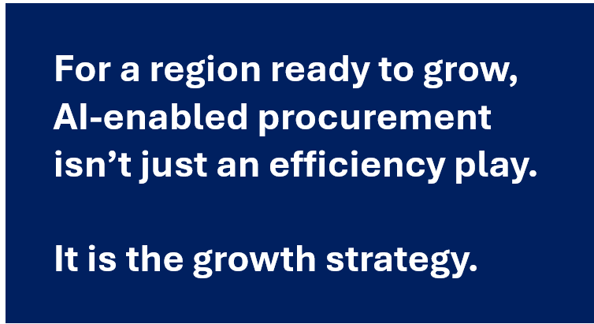
As Table 1 below shows, while AI is valuable in both sales and procurement, it can have a higher impact on EBITDA when applied to procurement and supply chain.

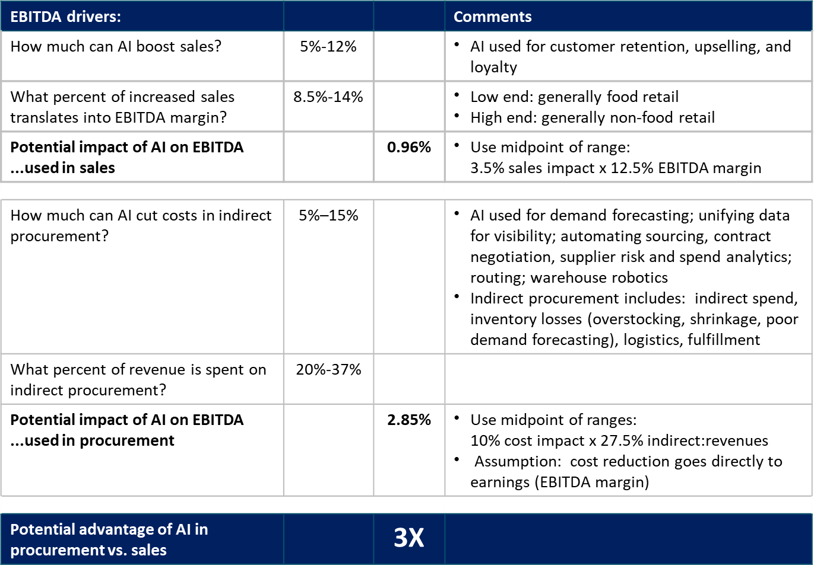

Table 1: Potential impact on EBITDA of AI solutions in sales and procurement

What Retail Leaders Should Prioritize

Table 2 below shows applications of AI in procurement that are immediately actionable with today’s technology.
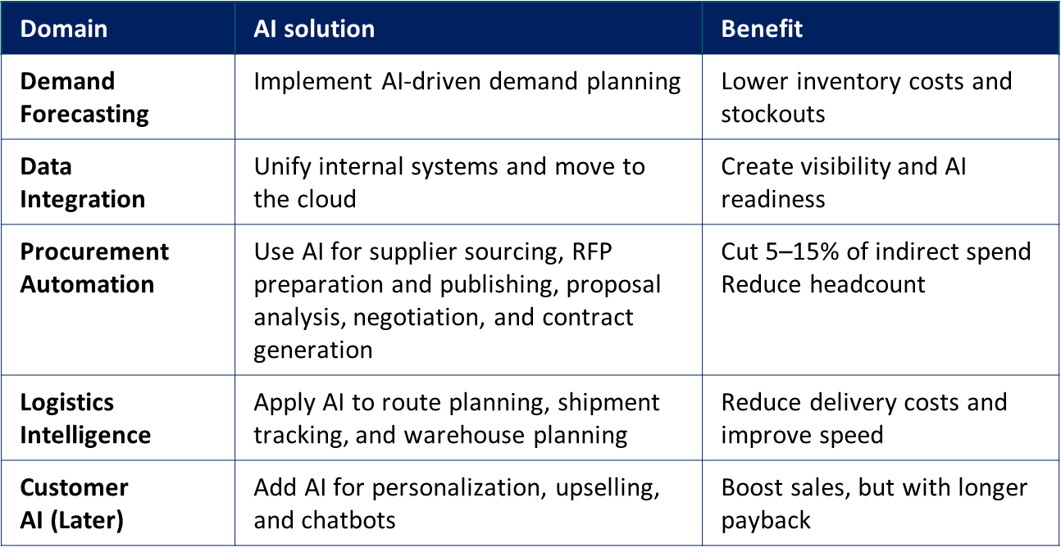

Table 2: Potential impact on EBITDA of AI solutions in sales and procurement

Betting Smart on Back-End AI

 | Latin America’s retail leaders face the same digital pressure as global counterparts, but with fewer tools and tighter margins. To future-proof operations and unlock meaningful EBITDA gains, the smarter bet isn’t customer-facing AI—it’s back-end AI in procurement and supply chains. It’s cheaper to deploy, faster to pay back, and foundational to everything that comes next.
For a region ready to grow, AI-enabled procurement isn’t just an efficiency play. It’s the growth strategy.

Author

Peter Benda is a general management consultant specializing in strategic sourcing and supply chain management, front line productivity improvement, governance, and diagnostics. He has worked with clients in mining, utilities, manufacturing, financial services, transportation, defense R&D, federal and state agencies, and technology startups. He is an advisor to procurement AI startup, Axtom. He has published market research and holds several patents.

Peter used ChatGPT to draft this article.

Keywords

#strategicsourcing #procurement #EBITDA #supplychain #latinamerica #retail #sales #revenue

Sources

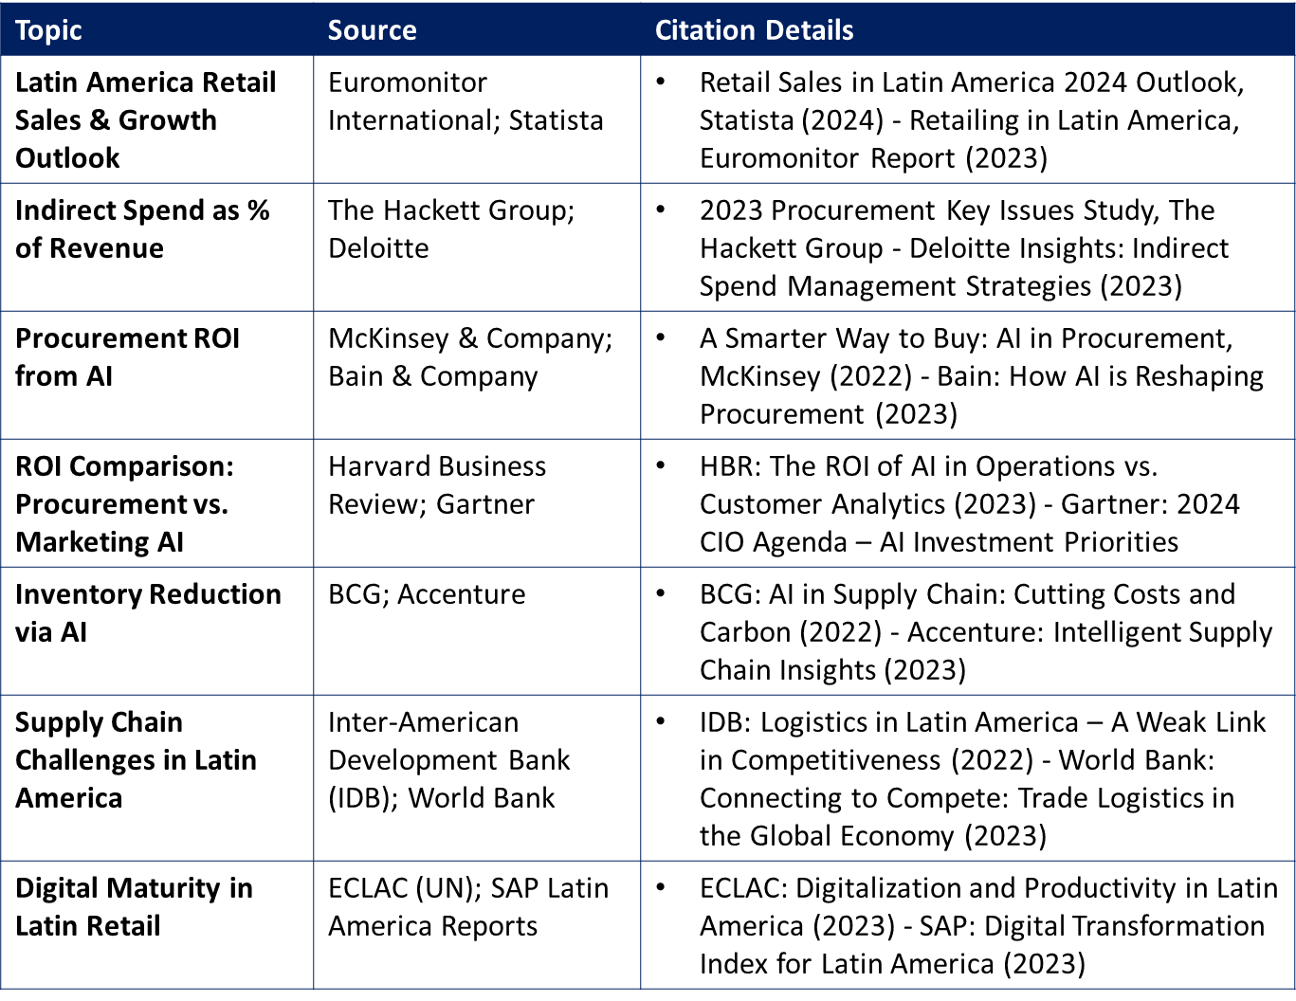

By line:

Don't just use AI to grow revenue. In Latin American retail, AI in procurement can drive EBITDA even more than in sales.

